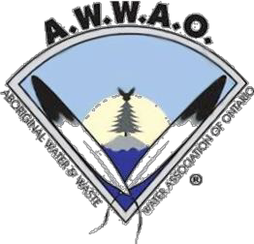
AWWAO 2021
MEMBERSHIP FORM

Board
of Directors

Place an X next to the membership you would like to join!!
Regular Member/Licensed Operator | $200.00
Associate | $400.00

Total Enclosed: $

Organization/First Nation: Name: Address: City: Prov.: Postal Code: Home: Cell: Work: Fax: Email: Current Certificate/License Level:
Waterdrum: Would you like to receive your newsletter by email? Yes _____ No ______

Please make cheques payable to:
AWWAO
Box 20001, RPO, Riverview Postal Outlet Dryden, ON P8N 0A1

*****Credit cards are not accepted.
Thank you for your support!

Ian Fortin Chairperson

Wes Morriseau
Vice Chairperson

Jason Fox
Secretary

Steve Laronde Treasurer

Phil Tangie
Director

Stacey Kicknosway Director

Sheryl St. Pierre
Director

Jonathan Riberdy
Director

